Projet Technologie XML et Web Services

1. **Partie Technologie XML** :
2. 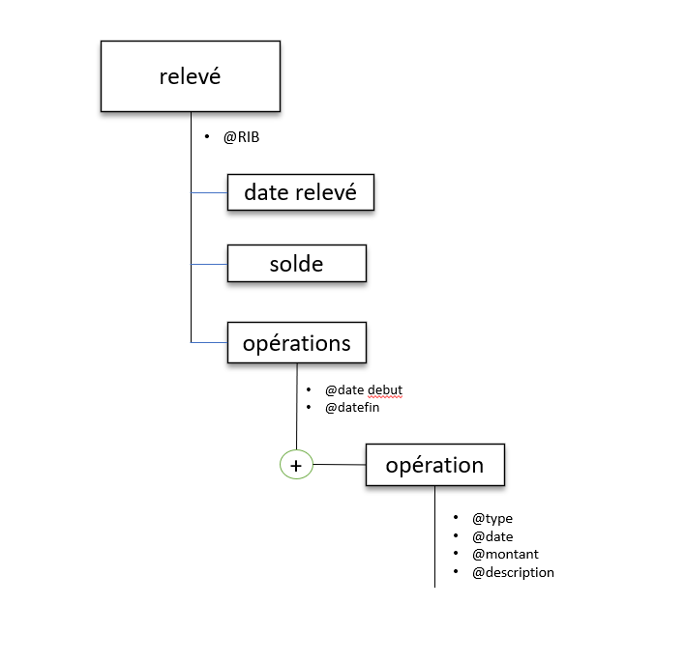 **structure graphique de l’arbre XML:**
3. 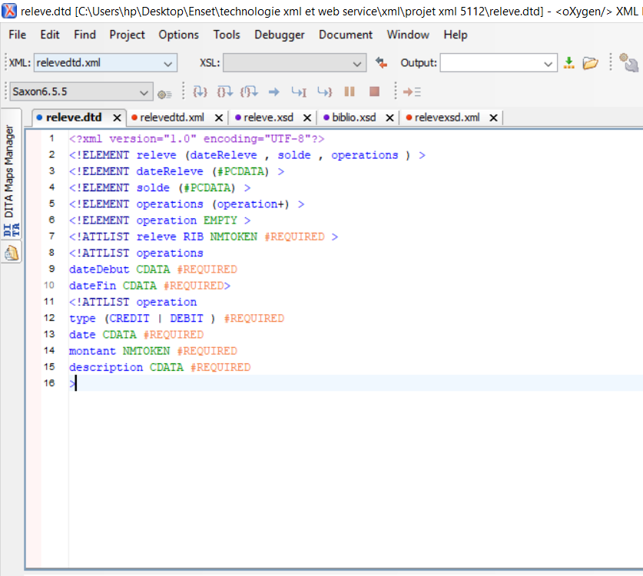 **DTD qui permet de déclarer la structure de ce document XML :**

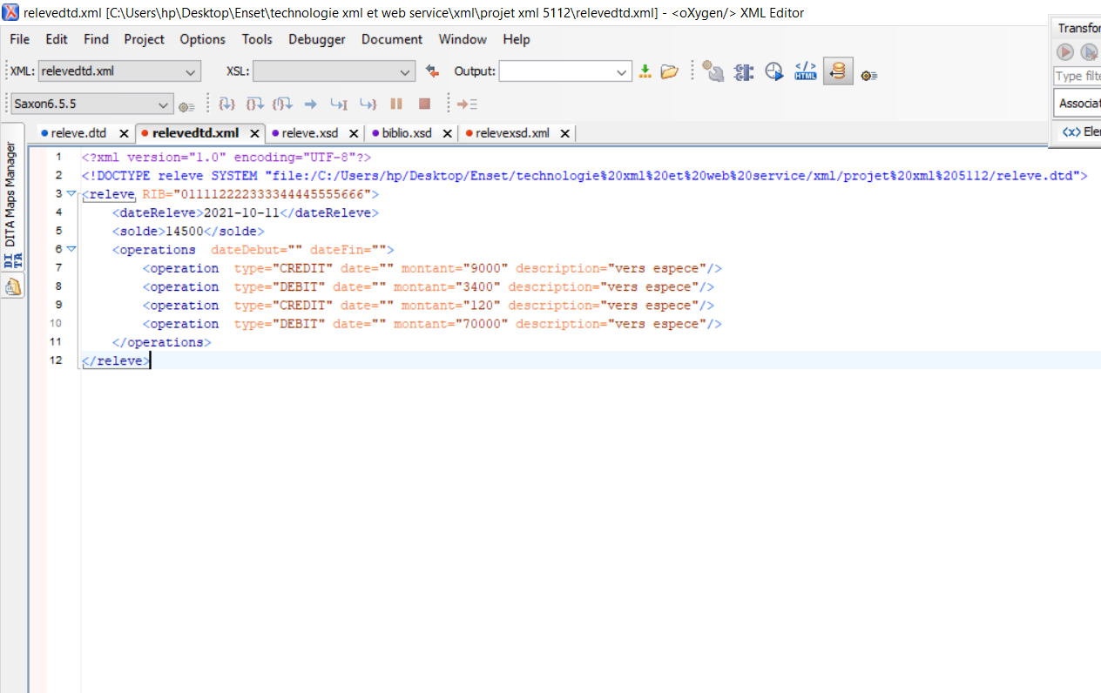-**document XML valide par ce DTD :**

1. 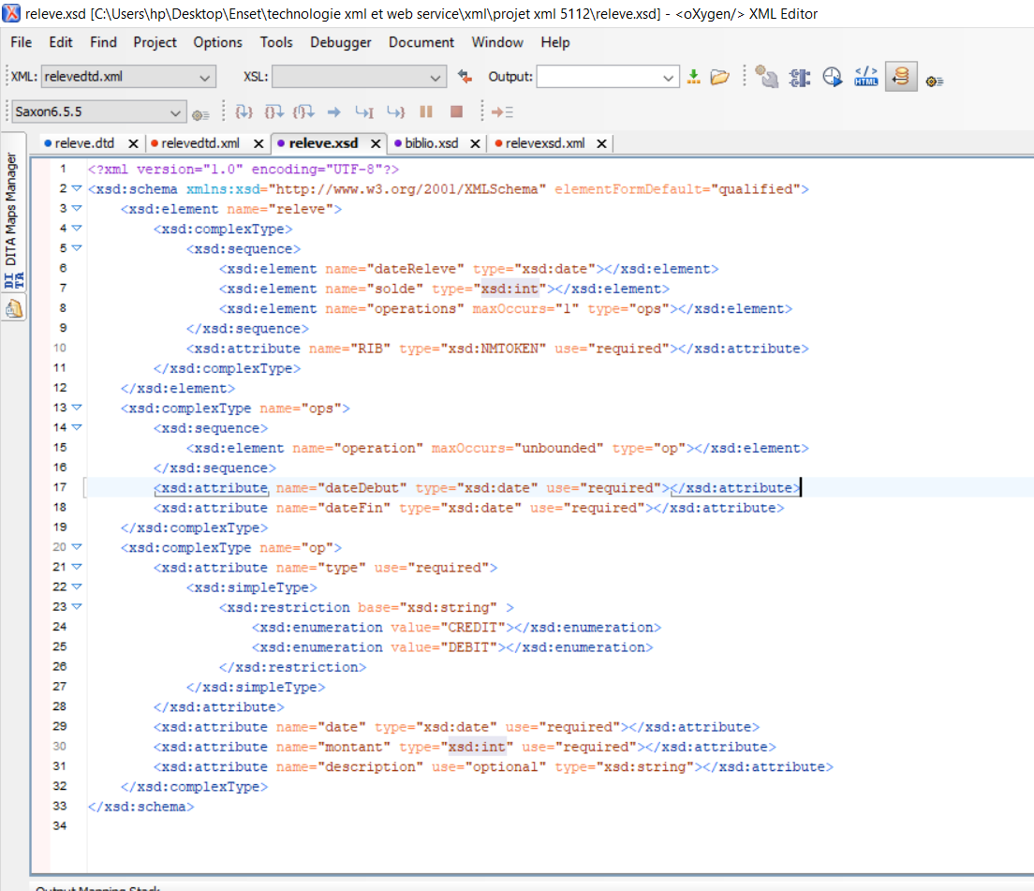**Schéma XML :**
2. feuille de style XSL qui permet d’afficher les toutes les données de ce document

XML au format HTML en affichant le total des opérations de débit et le total des

opérations de crédit.

<?xml version="1.0" encoding="UTF-8"?>  
<xsl:stylesheet xmlns:xsl="http://www.w3.org/1999/XSL/Transform" version="2.0">  
 <xsl:template match="/">  
 <html>  
 <head>  
 <title>releve</title>  
 </head>  
 <style>  
 h1{color:red}  
 h3{color:blue}  
   
 </style>  
 <body>  
 <h1>releve bancaire</h1>  
 <xsl:for-each select="releve">  
 <h3> RIB : <xsl:value-of select="@RIB"></xsl:value-of></h3>   
 <h3>dateReleve : <xsl:value-of select="dateReleve"></xsl:value of></h3>  
 <h3>Solde : <xsl:value-of select="solde"></xsl:value-of></h3>  
   
 <h4>les operations effectuee de <xsl:value-of select="operations/@dateDebut" ></xsl:value-of> vers <xsl:value-of select="operations/@dateFin" ></xsl:value-of></h4>  
 <table border="1" width="75%">  
 <tr>  
 <th>type</th><th>date</th><th>montant</th><th>description</th>  
 </tr>  
 <xsl:for-each select="operations/operation">  
 <tr>  
 <td><xsl:value-of select="@type"></xsl:value-of></td>  
 <td><xsl:value-of select="@date"></xsl:value-of></td>  
 <td><xsl:value-of select="@montant"></xsl:value-of></td>  
 <td><xsl:value-of select="@description"></xsl:value-of></td>  
 </tr>  
 </xsl:for-each>  
   
 <tr>  
 <td colspan="2">total montant debit :</td>  
 <xsl:for-each select="operations">  
 <td colspan="2" >  
 <xsl:value-of select="sum(operation[@type='DEBIT']/@montant)"></xsl:value-of>  
 </td>  
 </xsl:for-each>  
 </tr>  
 <tr>  
 <td colspan="2">total montant credit : </td>  
 <xsl:for-each select="operations">  
 <td colspan="2">   
 <xsl:value-of select="sum(operation[@type='CREDIT']/@montant)"></xsl:value-of>   
 </td>  
 </xsl:for-each>  
 </tr>  
 </table>  
   
 </xsl:for-each>  
 </body>  
 </html>  
 </xsl:template>  
</xsl:stylesheet>

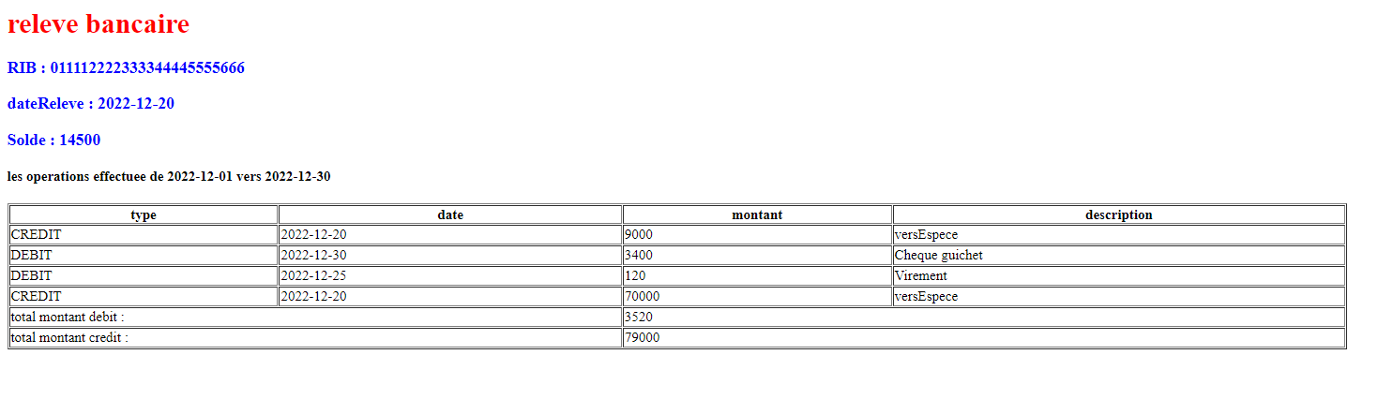-**transformation html :**

5. feuille de style XSL qui permet d’afficher au format HTML les opérations de type

CREDIT d’un relevé bancaire.

<?xml version="1.0" encoding="UTF-8"?>  
<xsl:stylesheet xmlns:xsl="http://www.w3.org/1999/XSL/Transform"  
 xmlns:xs="http://www.w3.org/2001/XMLSchema"  
 exclude-result-prefixes="xs"  
 version="2.0">  
 <xsl:template match="/">  
 <html>  
 <head>  
 <title>releve</title>  
 </head>  
 <style>  
 h1{color:red}  
 h3{color:blue}  
   
 </style>  
 <body>  
 <h1>releve bancaire</h1>  
 <xsl:for-each select="releve">  
 <h3> RIB : <xsl:value-of select="@RIB"></xsl:value-of></h3>   
 <h3>dateReleve : <xsl:value-of select="dateReleve"></xsl:value-of></h3>  
 <h3>Solde : <xsl:value-of select="solde"></xsl:value-of></h3>  
   
 <h4>les operations effectuee de <xsl:value-of select="operations/@dateDebut" ></xsl:value-of> vers <xsl:value-of select="operations/@dateFin" ></xsl:value-of></h4>  
 <table border="1" width="75%">  
 <tr>  
 <th>type</th><th>date</th><th>montant</th><th>description</th>  
 </tr>  
 <xsl:for-each select="operations/operation[@type='CREDIT']">  
 <tr>  
 <td><xsl:value-of select="@type" ></xsl:value-of></td>  
 <td><xsl:value-of select="@date"></xsl:value-of></td>  
 <td><xsl:value-of select="@montant"></xsl:value-of></td>  
 <td><xsl:value-of select="@description"></xsl:value-of></td>  
 </tr></xsl:for-each>  
 </table>  
   
 </xsl:for-each>  
 </body>  
 </html>  
 </xsl:template>  
</xsl:stylesheet>

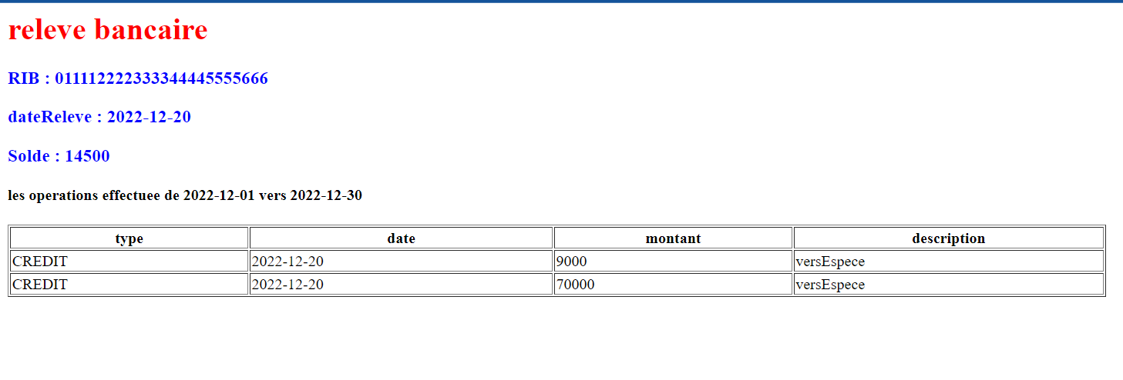**Presentation HTML:**